Form1.cs

using System;

using System.Collections.Generic;

using System.ComponentModel;

using System.Data;

using System.Drawing;

using System.Text;

using System.Windows.Forms;

using Microsoft.DirectX;

using Microsoft.DirectX.Direct3D;

namespace gppract1

{

public partial class Form1 : Form

{

Microsoft.DirectX.Direct3D.Device device;

public Form1()

{

InitializeComponent();

InitDevice();

}

private void InitDevice()

{

PresentParameters pp = new PresentParameters();

pp.Windowed = true;

pp.SwapEffect = SwapEffect.Discard;

device = new Device(0, DeviceType.Hardware, this, CreateFlags.HardwareVertexProcessing, pp);

}

private void Form1_Load(object sender, EventArgs e)

{

}

private void Render()

{

CustomVertex.TransformedColored[] vertexes = new CustomVertex.TransformedColored[6];

vertexes[0].Position = new Vector4(115, 85, 0, 1.0f);//first point

vertexes[0].Color = System.Drawing.Color.FromArgb(155, 255, 0).ToArgb();

vertexes[1].Position = new Vector4(690, 415, 0, 1.0f);//second point

vertexes[1].Color = System.Drawing.Color.FromArgb(155, 255, 0).ToArgb();

vertexes[2].Position = new Vector4(115, 415, 0, 1.0f);//second point

vertexes[2].Color = System.Drawing.Color.FromArgb(155, 255, 0).ToArgb();

device.Clear(ClearFlags.Target, Color.CornflowerBlue, 1.0f, 1);

device.BeginScene();

device.VertexFormat = CustomVertex.TransformedColored.Format;

device.DrawUserPrimitives(PrimitiveType.TriangleList, 1, vertexes);

device.EndScene();

device.Present();

}

private void Form1_Paint(object sender, PaintEventArgs e)

{

Render();

}

}

}

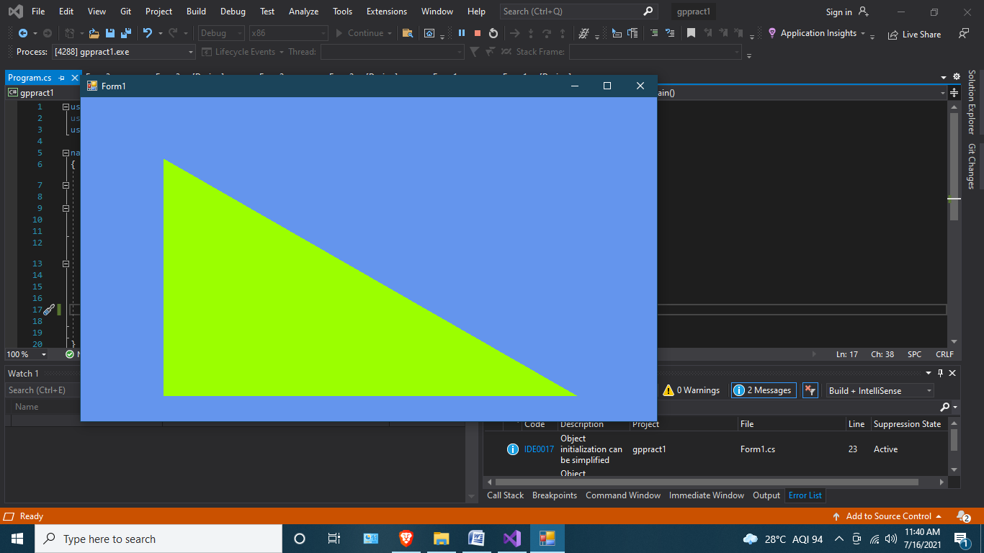

Form2.cs

using System;

using System.Collections.Generic;

using System.ComponentModel;

using System.Data;

using System.Drawing;

using System.Text;

using System.Windows.Forms;

using Microsoft.DirectX;

using Microsoft.DirectX.Direct3D;

namespace gppract1

{

public partial class Form2 : Form

{

Microsoft.DirectX.Direct3D.Device device;

public Form2()

{

InitializeComponent();

InitDevice();

}

private void InitDevice()

{

PresentParameters pp = new PresentParameters();

pp.Windowed = true;

pp.SwapEffect = SwapEffect.Discard;

device = new Device(0, DeviceType.Hardware, this, CreateFlags.HardwareVertexProcessing, pp);

}

private void Form2_Load(object sender, EventArgs e)

{

}

private void Render()

{

CustomVertex.TransformedColored[] vertexes = new CustomVertex.TransformedColored[6];

vertexes[0].Position = new Vector4(115, 85, 0, 1.0f);//first point

vertexes[0].Color = System.Drawing.Color.FromArgb(155, 255, 0).ToArgb();

vertexes[1].Position = new Vector4(690, 415, 0, 1.0f);//second point

vertexes[1].Color = System.Drawing.Color.FromArgb(155, 255, 0).ToArgb();

vertexes[2].Position = new Vector4(115, 415, 0, 1.0f);//second point

vertexes[2].Color = System.Drawing.Color.FromArgb(155, 255, 0).ToArgb();

vertexes[3].Position = new Vector4(115, 85, 0, 1.0f);//third point

vertexes[3].Color = System.Drawing.Color.FromArgb(0, 255, 115).ToArgb();

vertexes[4].Position = new Vector4(690, 85, 0, 1.0f);//4th point

vertexes[4].Color = System.Drawing.Color.FromArgb(0, 255, 115).ToArgb();

vertexes[5].Position = new Vector4(690, 415, 0, 1.0f);//5th point

vertexes[5].Color = System.Drawing.Color.FromArgb(0, 255, 115).ToArgb();

device.Clear(ClearFlags.Target, Color.CornflowerBlue, 1.0f, 1);

device.BeginScene();

device.VertexFormat = CustomVertex.TransformedColored.Format;

device.DrawUserPrimitives(PrimitiveType.TriangleList, 2, vertexes);

device.EndScene();

device.Present();

}

private void Form2_Paint(object sender, PaintEventArgs e)

{

Render();

}

}

}

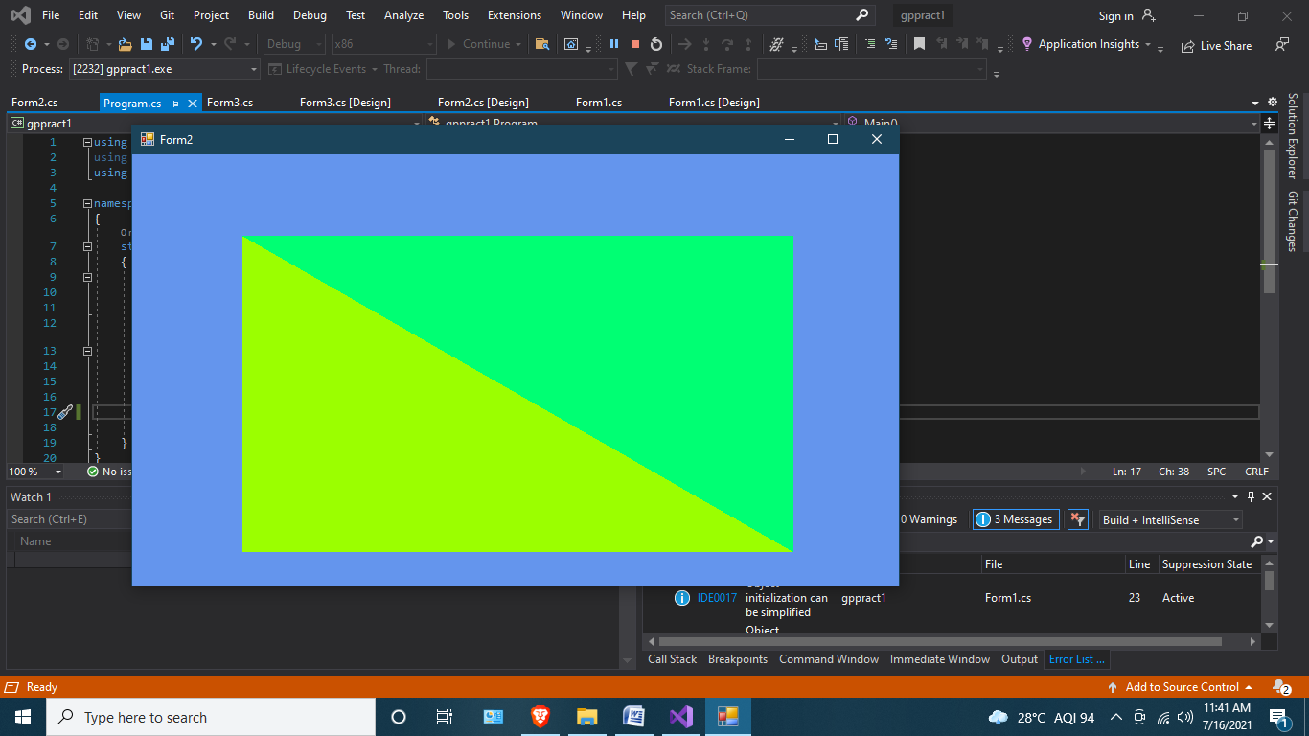

Form3.cs

using System;

using System.Collections.Generic;

using System.ComponentModel;

using System.Data;

using System.Drawing;

using System.Text;

using System.Windows.Forms;

using Microsoft.DirectX;

using Microsoft.DirectX.Direct3D;

namespace gppract1

{

public partial class Form3 : Form

{

Microsoft.DirectX.Direct3D.Device device;

public Form3()

{

InitializeComponent();

InitDevice();

}

private void InitDevice()

{

PresentParameters pp = new PresentParameters();

pp.Windowed = true;

pp.SwapEffect = SwapEffect.Discard;

device = new Device(0, DeviceType.Hardware, this, CreateFlags.HardwareVertexProcessing, pp);

}

private void Form3_Load(object sender, EventArgs e)

{

}

private void Render()

{

CustomVertex.TransformedColored[] vertexes = new CustomVertex.TransformedColored[9];

vertexes[0].Position = new Vector4(202,175, 0, 1.0f);//first point

vertexes[0].Color = System.Drawing.Color.FromArgb(255, 255, 0).ToArgb();

vertexes[1].Position = new Vector4(315, 85, 0, 1.0f);//second point

vertexes[1].Color = System.Drawing.Color.FromArgb(255, 255, 0).ToArgb();

vertexes[2].Position = new Vector4(425, 175, 0, 1.0f);//second point

vertexes[2].Color = System.Drawing.Color.FromArgb(255, 255, 0).ToArgb();

vertexes[3].Position = new Vector4(425,175, 0, 1.0f);//third point

vertexes[3].Color = System.Drawing.Color.FromArgb(0, 255, 255).ToArgb();

vertexes[4].Position = new Vector4(380,315, 0, 1.0f);//4th point

vertexes[4].Color = System.Drawing.Color.FromArgb(0, 255, 255).ToArgb();

vertexes[5].Position = new Vector4(245,315, 0, 1.0f);//5th point

vertexes[5].Color = System.Drawing.Color.FromArgb(0, 255, 255).ToArgb();

vertexes[6].Position = new Vector4(245, 315, 0, 1.0f);//6th point

vertexes[6].Color = System.Drawing.Color.FromArgb(255, 255, 255).ToArgb();

vertexes[7].Position = new Vector4(202, 175, 0, 1.0f);//7th point

vertexes[7].Color = System.Drawing.Color.FromArgb(255, 255, 255).ToArgb();

vertexes[8].Position = new Vector4(425, 175, 0, 1.0f);//8th point

vertexes[8].Color = System.Drawing.Color.FromArgb(255, 255, 255).ToArgb();

device.Clear(ClearFlags.Target, Color.CornflowerBlue, 1.0f, 1);

device.BeginScene();

device.VertexFormat = CustomVertex.TransformedColored.Format;

device.DrawUserPrimitives(PrimitiveType.TriangleList, 3, vertexes);

device.EndScene();

device.Present();

}

private void Form3_Paint(object sender, PaintEventArgs e)

{

Render();

}

}

}

